## Tablayout

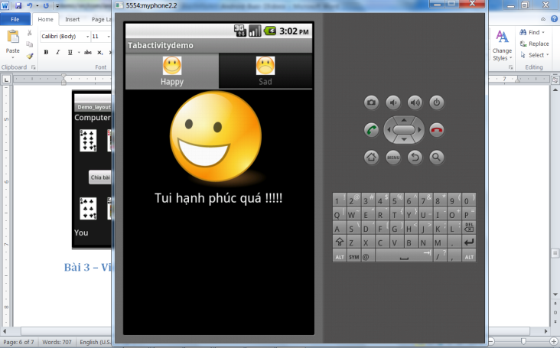 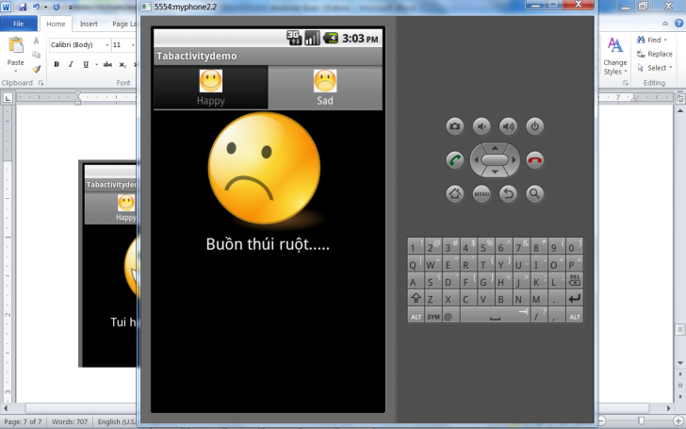

1. Tạo giao diện cho chương trình chính với thẻ root là TabHost chứ không phải là LinearLayout bên trong là tabwidget, và framelayout. Nếu kéo bằng tabhost nó phát sinh ra tùm lum, xóa bớt đi vì ta sẽ add tab trong file java.

<?xml version=*"1.0"* encoding=*"utf-8"*?>

<TabHost xmlns:android=*"http://schemas.android.com/apk/res/android"*

android:id=*"@android:id/tabhost"*

android:layout_width=*"match_parent"*

android:layout_height=*"match_parent"* >

<LinearLayout

android:layout_width=*"match_parent"*

android:layout_height=*"match_parent"*

android:orientation=*"vertical"* >

<TabWidget

android:id=*"@android:id/tabs"*

android:layout_width=*"match_parent"*

android:layout_height=*"wrap_content"* >

</TabWidget>

<FrameLayout

android:id=*"@android:id/tabcontent"*

android:layout_width=*"match_parent"*

android:layout_height=*"match_parent"* >

</FrameLayout>

</LinearLayout>

</TabHost>

Tạo giao diện con happy.xml

<?xml version=*"1.0"* encoding=*"utf-8"*?>

<LinearLayout xmlns:android=*"http://schemas.android.com/apk/res/android"*

android:layout_width=*"match_parent"*

android:layout_height=*"match_parent"*

android:orientation=*"vertical"* >

<ImageView

android:id=*"@+id/imageView1"*

android:layout_width=*"wrap_content"*

android:layout_height=*"wrap_content"*

android:src=*"@drawable/happy"*

android:layout_gravity=*"center"*

/>

<TextView

android:id=*"@+id/textView1"*

android:layout_width=*"wrap_content"*

android:layout_height=*"wrap_content"*

android:text=*"Tui hạnh phúc quá !!!!!"*

android:layout_gravity=*"center"*

android:textAppearance=*"?android:attr/textAppearanceLarge"* />

</LinearLayout>

Tạo giao diện con sad.xml

<?xml version=*"1.0"* encoding=*"utf-8"*?>

<LinearLayout xmlns:android=*"http://schemas.android.com/apk/res/android"*

android:layout_width=*"match_parent"*

android:layout_height=*"match_parent"*

android:orientation=*"vertical"* >

<ImageView

android:id=*"@+id/imageView1"*

android:layout_width=*"wrap_content"*

android:layout_height=*"wrap_content"*

android:src=*"@drawable/sad"*

android:layout_gravity=*"center"*/>

<TextView

android:id=*"@+id/textView1"*

android:layout_width=*"wrap_content"*

android:layout_height=*"wrap_content"*

android:text=*"Buồn thúi ruột....."*

android:layout_gravity=*"center"*

android:textAppearance=*"?android:attr/textAppearanceLarge"* />

</LinearLayout>

Chép hình vào thư mục.

Tạo 2 activity là happyActivity.java và sadActivity.java

happyActivity.java

**public** **class** happyActivity **extends** Activity {

@Override

**protected** **void** onCreate(Bundle savedInstanceState) {

// **TODO** Auto-generated method stub

**super**.onCreate(savedInstanceState);

setContentView(R.layout.*happy*);

}

}

sadActivity.java

**public** **class** sadActivity **extends** Activity{

@Override

**protected** **void** onCreate(Bundle savedInstanceState) {

// **TODO** Auto-generated method stub

**super**.onCreate(savedInstanceState);

setContentView(R.layout.*sad*);

}

}

Mở manifest.xml thêm 2 activity vừa tạo.

Code chương trinh chính. Nhớ kế thừa từ TabActivity thay cho Activity nhé.

**public** **class** TabactivitydemoActivity **extends** TabActivity {

/** Called when the activity is first created. */

@Override

**public** **void** onCreate(Bundle savedInstanceState) {

**super**.onCreate(savedInstanceState);

setContentView(R.layout.*main*);

TabHost tabhost= getTabHost();

//con happy

TabSpec tabHappy=tabhost.newTabSpec("happy");

tabHappy.setIndicator("Happy",

getResources().getDrawable(R.drawable.*happy_small*));

Intent h=**new** Intent(**this**,happyActivity.**class**);

tabHappy.setContent(h);

tabhost.addTab(tabHappy);

//con sad

TabSpec tabSad=tabhost.newTabSpec("sad");

tabSad.setIndicator("Sad", getResources().getDrawable(R.drawable.*sad_small*));

Intent s=**new** Intent(**this**,sadActivity.**class**);

tabSad.setContent(s);

tabhost.addTab(tabSad);

tabhost.setCurrentTab(0);

}

}

## Dua tab xuong duoi

LinearLayout trong tabhost doi thanh framelayout

Tabwidget them android:layout_gravity=*"bottom"*

## Doi mau cho tab

Trong onCreate

//tabhost.getChildAt(0).setBackgroundColor(Color.parseColor("#00ff00"));

**for**(**int** i=0;i<2;i++)

{

tabhost.getTabWidget().getChildAt(i).setBackgroundColor(Color.*parseColor*("#ff0000"));

}

tabhost.setCurrentTab(0);

tabhost.getTabWidget().getChildAt(tabhost.getCurrentTab()).setBackgroundColor(Color.*parseColor*("#0000ff"));

tabhost.setOnTabChangedListener(**new** OnTabChangeListener() {

**public** **void** onTabChanged(String tabId) {

// **TODO** Auto-generated method stub

**for**(**int** i=0;i<2;i++)

{

getTabWidget().getChildAt(i).setBackgroundColor(Color.*parseColor*("#ff0000"));

}

getTabWidget().getChildAt(tabhost.getCurrentTab()).setBackgroundColor(Color.*parseColor*("#0000ff"));

}

});

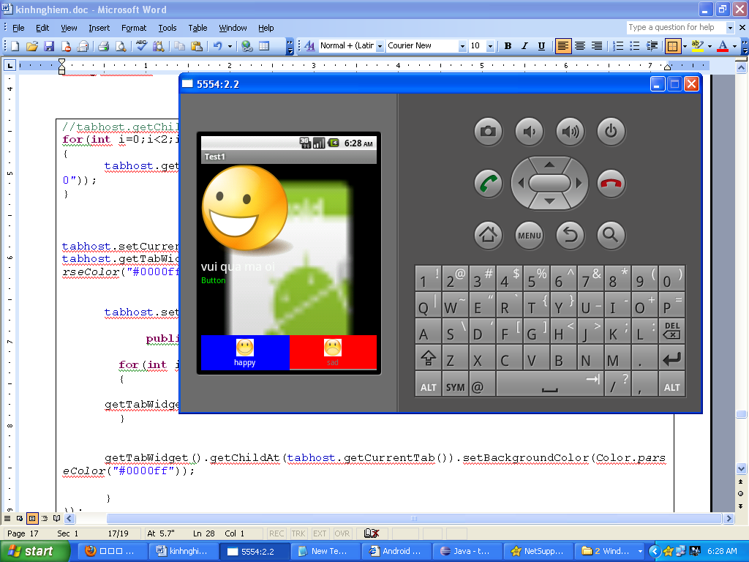

# An cay gach den ben duoi tab

tabhost.getTabWidget().setStripEnabled(**false**);//khong cho cay gach xam ben duoi

# Hien gach den suot ben duoi cho dep

Giua tabwidget va frame layout them mot view trong nhu ben duoi

<View

android:layout_width=*"fill_parent"*

android:layout_height=*"1dp"*

android:background=*"@android:color/darker_gray"* />

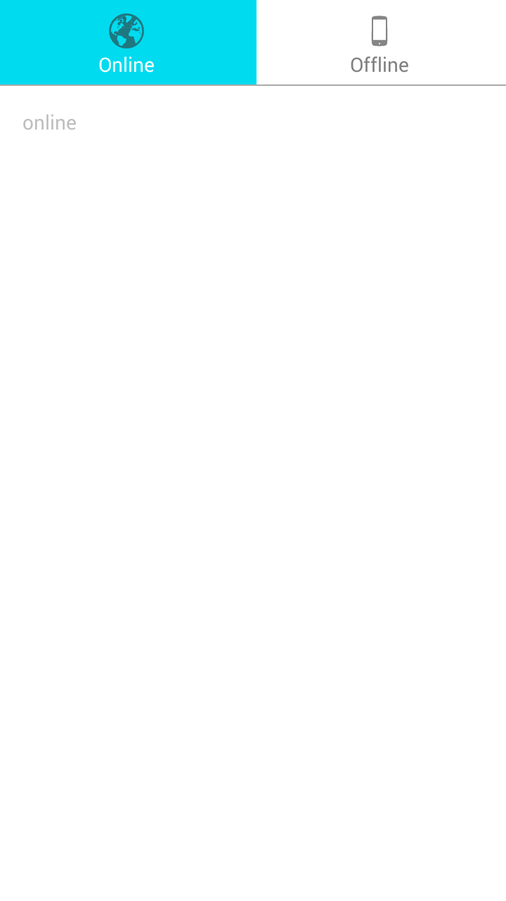

Thiet ke theo kieu nhaccuatui

# Cuon nhieu tab, them HorizontalScrollView vao

## 

Vấn đề khi bên ngoài tabhost nằm trong 1 layoutout khác

Tabhost nằm trong 1 linearlayout thì nó sẽ lỗi phần activity con (activity chon hiện lên trên). Khi đó xem mã bên dưới.

Để ý thấy ngoài cùng là linearlayout, trong có 1 view rồi mới đến tabhost, khi đó sẽ lỗi activity.

Khi đó ta phải sửa thêm 1 linearlayout nữa bao phần tabwidget và framelayout.

<?xml version=*"1.0"* encoding=*"utf-8"*?>

<LinearLayout xmlns:android=*"http://schemas.android.com/apk/res/android"*

android:layout_width=*"match_parent"*

android:layout_height=*"match_parent"*

android:background=*"#ffffff"*

android:orientation=*"vertical"* >

<View

android:layout_width=*"fill_parent"*

android:layout_height=*"50dp"*

android:background=*"#000000"* />

<TabHost

android:id=*"@android:id/tabhost"*

android:layout_width=*"match_parent"*

android:layout_height=*"match_parent"* >

<LinearLayout android:orientation=*"vertical"*

android:layout_width=*"fill_parent"* android:layout_height=*"fill_parent"*

android:padding=*"5dp"*>

<TabWidget

android:id=*"@android:id/tabs"*

android:layout_width=*"match_parent"*

android:layout_height=*"wrap_content"* >

</TabWidget>

<View

android:layout_width=*"fill_parent"*

android:layout_height=*"1dp"*

android:background=*"@android:color/darker_gray"* />

<FrameLayout

android:id=*"@android:id/tabcontent"*

android:layout_width=*"match_parent"*

android:layout_height=*"match_parent"* >

</FrameLayout>

</LinearLayout>

</TabHost>

</LinearLayout>

Trong java khai bien toan cuc

~~LocalActivityManager~~ mLocalActivityManager;

Trong onCreate anh xạ tabhost và viết như sau

tabhost = (TabHost) findViewById(android.R.id.*tabhost*);

mLocalActivityManager = **new** LocalActivityManager(**this**, **false**);

mLocalActivityManager.dispatchCreate(savedInstanceState);

tabhost.setup(mLocalActivityManager);